TECHNICAL SPECIFICATION

Rectangular hollow structural sections:

1. Metallic Box- 80x80x4-6000 mm

TECHNICAL SPECIFICATION
N | Description | Unit | Requirement
 | Dimensions AxA | mm | 80x80
 | Thickness | mm | 4
 | Material |  | S235 Jr. acc –En-10025  Acc-EN-10130
 | Standard |  | EN-102219-1 and 2
 | length | m | 6

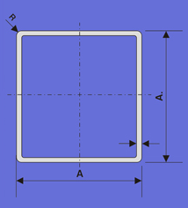

2. Metallic Box- 60x60x4-6000 mm

TECHNICAL SPECIFICATION
N | Description | Unit | Requirement
 | Dimensions AxA | mm | 60x60
 | Thickness | mm | 4
 | Material |  | S235 Jr. acc –En-10025  Acc-EN-10130
 | Standard |  | EN-102219-1 and 2
 | Length | m | 6

3. Metallic Box- 60x40x4-6000 mm

TECHNICAL SPECIFICATION
N | Description | Unit | Requirement
 | Dimensions AxA | mm | 60x40
 | Thickness | mm | 4
 | Material |  | S235 Jr. acc –En-10025  Acc-EN-10130
 | Standard |  | EN-102219-1 and 2
 | Length | m | 6

4. Metallic Box- 40x40x3-6000 mm

TECHNICAL SPECIFICATION
N | Description | Unit | Requirement
 | Dimensions AxA | mm | 40x40
 | Thickness | mm | 3
 | Material |  | S235 Jr. acc –En-10025  Acc-EN-10130
 | Standard |  | EN-102219-1 and 2
 | Length | m | 6

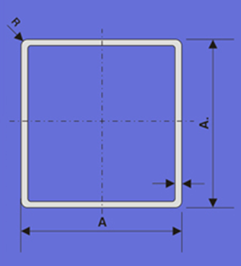

5. Metallic Box- 40x20x2-6000 mm

TECHNICAL SPECIFICATION
N | Description | Unit | Requirement
 | Dimensions AxA | mm | 40x20
 | Thickness | mm | 2
 | Material |  | S235 Jr. acc –En-10025  Acc-EN-10130
 | Standard |  | EN-102219-1 and 2
 | Length | m | 6

6. Metallic Box- 20x20x2-6000 mm

TECHNICAL SPECIFICATION
N | Description | Unit | Requirement
 | Dimensions AxA | mm | 20x20
 | Thickness | mm | 2
 | Material |  | S235 Jr. acc –En-10025  Acc-EN-10130
 | Standard |  | EN-102219-1 and 2
 | Length | m | 6

7. Metal Profile”L” – 70x70x7-6000 mm

TECHNICAL SPECIFICATION
N | Description | Unit | Requirement
 | Dimensions AxA | mm | 70x70
 | Thickness | mm | 7
 | Material |  | S235 Jr. acc –En-10025  Acc-EN-10130
 | Standard |  | EN-102219-1 and 2
 | Length | m | 6

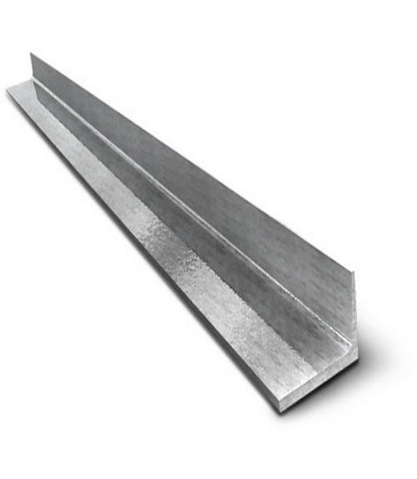

8. Metal Profile”L” - 50x50x5-6000 mm

TECHNICAL SPECIFICATION
N | Description | Unit | Requirement
 | Dimensions AxA | mm | 50x50
 | Thickness | mm | 5
 | Material |  | S235 Jr. acc –En-10025  Acc-EN-10130
 | Standard |  | EN-102219-1 and 2
 | Length | m | 6

9. Metal Profile” - 40x40x4-6000 mm

TECHNICAL SPECIFICATION
N | Description | Unit | Requirement
 | Dimensions AxA | mm | 40x40
 | Thickness | mm | 4
 | Material |  | S235 Jr. acc –En-10025  Acc-EN-10130
 | Standard |  | EN-102219-1 and 2
 | Length | m | 6

10. Metal Profile” - 35x35x4-6000 mm

TECHNICAL SPECIFICATION
N | Description | Unit | Requirement
 | Dimensions AxA | mm | 35x35
 | Thickness | mm | 4
 | Material |  | S235 Jr. acc –En-10025  Acc-EN-10130
 | Standard |  | EN-102219-1 and 2
 | Length | m | 6

11. Metal Profile” – 80x80x8-6000 mm

TECHNICAL SPECIFICATION
N | Description | Unit | Requirement
 | Dimensions AxA | mm | 80x80
 | Thickness | mm | 8
 | Material |  | S235 Jr. acc –En-10025  Acc-EN-10130
 | Standard |  | EN-102219-1 and 2
 | Length | m | 6

12. Metal Profile” – 80x5x6-6000 mm

TECHNICAL SPECIFICATION
N | Description | Unit | Requirement
 | Dimensions AxB | mm | 80x5
 | Thickness | mm | 6
 | Material |  | S235 Jr. acc –En-10025  Acc-EN-10130
 | Standard |  | EN-102219-1 and 2
 | Length | m | 6

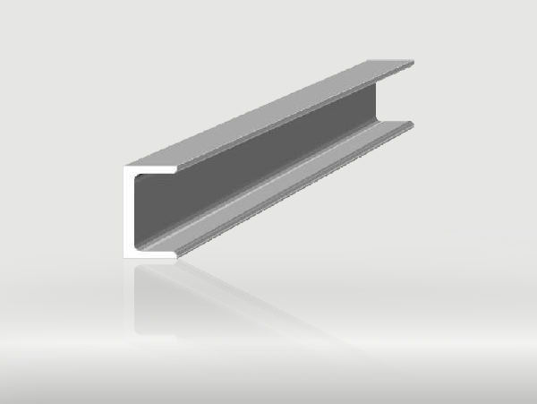

13. Iron sheet – 2000x1000x1.5mm

TECHNICAL SPECIFICATION
N | Description | Unit | Requirement
 | Dimensions AxB | mm | 2000x1000
 | Thickness | mm | 1.5
 | Material |  | S235 Jr. acc –En-10025  Acc-EN-10130
 | Standard |  | EN-102219-1 and 2
 | Length | m

